
Information Systems & Software Engineering Department

Capstone Project Phase B – 61999
Deepfake Detectors - Zero Shot & Few shot

26-1-R-8

Students:
Chen Tsafir 319005104
Nir Haim Glick 207851155

Supervisors:
Dr. Renata Avros
Prof. Zeev (Vladimir) Volkovich

Git Repository: https://github.com/Deepfake-Detectors-Phases-A&B

Abstract 3
1 Introduction 3
2 Theoretical Background 4
2.1 Deepfake Generation Methods – SimSwap 4
2.2 Traditional Detection and Self-Blended Images (SBI) 5
2.3 InstructBLIP 6
2.4 Zero-Shot and Few-Shot Learning 7
3 Methodology 7
3.1 System overview 7
3.2 Probabilistic Inference Algorithm 8
3.3 Training and Fine-tuning Strategy 9
3.4 System Inputs 10
3.4.1 Visual datasets 10
3.4.2 Prompt Design 10
4 Results and Evaluation 11
4.1 System Implementation Overview 11
4.2 Unit Testing and Validation 12
4.3 Evaluation Methodology 12
4.4 InstructBLIP Results 13
4.5 SBI Baseline - Implementation & Results 16
4.6 Comparative Analysis: VLM vs. Traditional Detector 19
4.7 Challenges, Key Decisions and Lessons Learned 19
4.8 Project Goals Assessment 21
5 Conclusion and Future Work 22
6 References List 23

Abstract
This study investigates the efficacy of Visual Language Models (VLMs), specifically the InstructBLIP architecture, as deepfake detectors capable of addressing the generalization limitations of traditional binary classifiers. While state-of-the-art generative methods like SimSwap produce high-fidelity forgeries with minimal visual artifacts, traditional detection methods such as Self-Blended Images (SBI) often struggle to generalize to unseen attacks. This gap arises because most existing detectors focus on low-level visual artifacts and blending boundaries, whereas VLMs leverage broad semantic understanding acquired from massive pre-training, resulting in greater robustness against out-of-distribution samples.
This project reframes binary deepfake classification as a visual question-answering task using InstructBLIP. To learn deepfake-specific anomalies without catastrophic forgetting, a Parameter-Efficient Fine-Tuning (PEFT) strategy is applied, training exclusively the Q-Former component while freezing the LLM and vision encoder. At its methodological core, the system utilizes a probabilistic inference algorithm that bypasses standard text generation. By extracting and normalizing the logits of specific decision tokens ("Yes"/"No"), the model's generative output is converted into a continuous, calibrated confidence score suitable for standard classification metrics.
System performance was evaluated under Zero-Shot and Few-Shot (1:10) scenarios on challenging datasets, including a custom SimSwap-based benchmark, and benchmarked against SBI as a traditional baseline. Validation was conducted using AUC, EER, and bootstrap confidence intervals, alongside an embedding-space clustering analysis (t-SNE, Silhouette Score). This analysis revealed that classification is driven primarily by the model's terminal decision layer rather than by linearly separable internal representations, offering a structural insight into how VLMs perform deepfake detection.

Introduction
In recent years, deepfake technology has evolved from a technological curiosity into a true everyday threat, driven by free computing resources such as Google Colab and accessible tools like SimSwap and ComfyUI. This phenomenon poses a growing challenge to Know Your Customer systems, biometric verification mechanisms, and media platforms; according to recent reports, deepfake-based identity fraud has quadrupled in just one year.
Most existing detection methods, such as FaceForensics++ or frequency-based models like M2TR, operate as "pixel detectives", focusing on visual artifacts or hidden noise at the pixel level. Advanced methods such as Self-Blended Images (SBI) achieve impressive performance by generating synthetic training samples that mimic forgery artifacts. However, these approaches still suffer from limited generalization: they tend to overfit the manipulation methods they were trained on and prove fragile when exposed to simple alterations such as compression and noise. Their central limitation is an inability to comprehend the broader semantic content of an image, restricting their capacity to cope with unseen threats in zero-shot scenarios.
To address this gap, this project proposes an approach based on Visual Language Models (VLMs), specifically the InstructBLIP architecture. These models combine a frozen Image Encoder with a frozen Large Language Model (LLM), connected via a dedicated Q-Former component that interprets natural language instructions. The central hypothesis is that the zero-shot capabilities and deep semantic understanding acquired during massive pre-training allow for more robust forgery detection than models trained solely for a specific classification task.
A key challenge in applying VLMs to security applications is that their natural generative output is free text (e.g., a binary "Yes"/"No" answer), which provides no continuous confidence score for thresholding or calculating metrics such as AUC. This project addresses that gap by transforming the generative model into a probabilistic classifier. By analyzing the predicted token distribution and applying normalization exclusively over the restricted "Yes"/"No" token subset-rather than the full vocabulary-the system yields a probability vector that faithfully reflects the model's confidence between the two relevant options.
Ultimately, the goal of this project was to evaluate whether VLMs can serve as effective deepfake detectors across both zero-shot and few-shot regimes. Using a challenging custom dataset based on CelebA-HQ and SimSwap, alongside established benchmarks such as DFDC, the research assesses whether lightweight adaptation-fine-tuning only the Q-Former component-enables robust generalization to unseen manipulation methods, a capability traditional fully-supervised detectors such as SBI struggle to achieve.

Theoretical Background
This chapter establishes the theoretical foundations required to understand the proposed solution. It reviews the evolution of Deepfake generation and detection, introduces the paradigm of Vision-Language Models (VLMs), details the specific architecture of InstructBLIP, and defines the mathematical concepts used for probabilistic classification in generative models.

Deepfake Generation Methods – SimSwap
Modern face-swapping relies heavily on Generative Adversarial Networks (GANs) and recent diffusion-based techniques. A prominent example used in modern datasets is SimSwap.
SimSwap is a state-of-the-art (SOTA) framework designed for high-fidelity, generalized one-shot face swapping. The primary objective is to transfer the identity of a source face $(I_{S})$ onto a target face $(I_{T})$ while maintaining the targets’ specific attributes, including expression, pose, lighting, and gaze direction.
To overcome the limitations of identity-specific models that require separate decoders, SimSwap introduces the Identity Injection Module (IIM). Positioned between the encoder and decoder, the IIM facilitates generalization by replacing target identity features with source identity information.

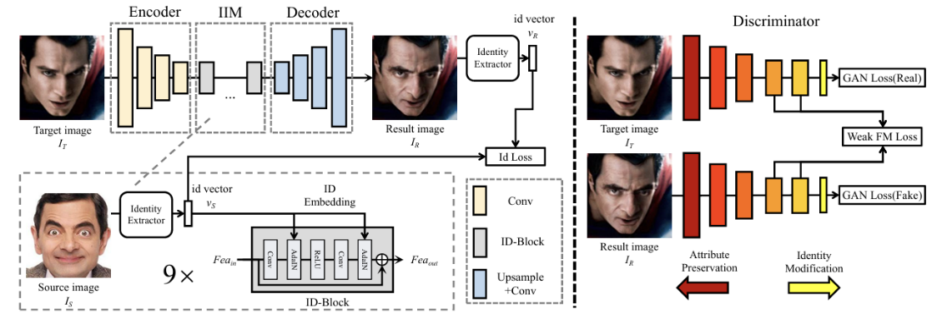

Figure 1: High-fidelity face swapping results demonstrating identity transfer while preserving attributes. Source: Chen et al., “SimSwap: An Efficient Framework for High Fidelity Face Swapping” (2020)

Traditional Detection and Self-Blended Images (SBI)
Traditional detectors rely on CNN backbones (e.g., Xception, EfficientNet) trained as binary classifiers - often termed "Pixel Detectives" for their focus on low-level frequency artifacts and blending boundaries. While effective on familiar manipulation methods, these detectors tend to overfit their training distribution and fail to generalize to unseen attack types.

Self-Blended Images (SBI) is a synthetic data generation technique designed to address this limitation. Rather than requiring pairs of different identities, SBI generates fake training samples from a single real face image. A Source-Target Generator (STG) introduces statistical and spatial discrepancies into a copy of the base image, a Mask Generator (MG) defines a facial blending region using landmark-based convex hull estimation, and the final SBI is produced by merging the two through the blended mask. This pipeline encourages the detector to learn generic visual inconsistencies blending boundaries, color shifts, frequency distortions - rather than manipulation-specific artifacts, improving cross-dataset robustness.
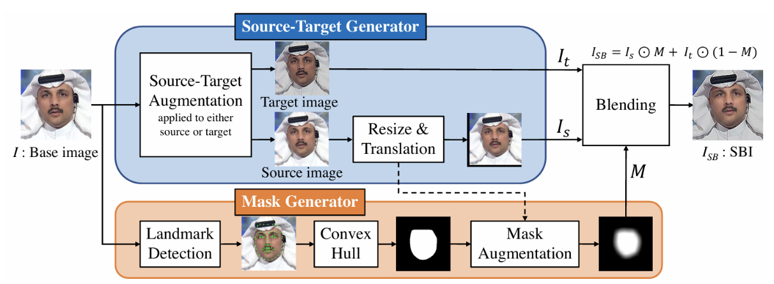
Figure 2: The Self-Blended Images (SBI) generation pipeline, creating synthetic training samples from a single source image. Source: Shiohara & Yamasaki, “Detecting Deepfakes with Self-Blended Images” (2022).

InstructBLIP
While methods like SBI focus on synthesizing spatial artifacts to train binary classifiers, InstructBLIP represents a paradigm shift towards general-purpose vision-language modeling. InstructBLIP is a vision-language instruction tuning framework designed to enable models to solve a wide range of tasks through a unified natural language interface.

Unlike traditional detectors that require task-specific heads, InstructBLIP initializes training with a pre-trained BLIP-2 model, consisting of an Image Encoder, a Large Language Model (LLM), and a Query Transformer (Q-Former) to bridge the two. Its core innovation lies in its Instruction-Aware Visual Feature Extraction, which allows the model to extract visual features tailored specifically to the given instruction
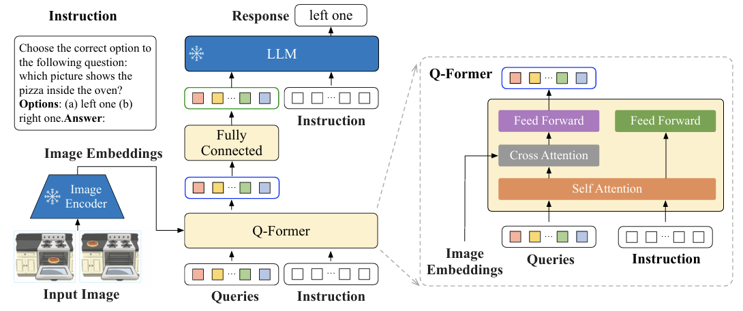
Figure 3: The InstructBLIP architecture illustrating the instruction-aware Q-Former mechanism. Source: Dai et al., “InstructBLIP: Towards General-purpose Vision-Language Models with Instruction Tuning” (2023).

The architecture comprises three primary components:
- Frozen Image Encoder: The visual input is processed by a Vision Transformer (specifically ViT-g/14). This component remains frozen during instruction tuning, preserving the robust visual representations learned during massive pre-training.
- Instruction-Aware Q-Former: The Query Transformer acts as a bottleneck module that bridges the modality gap. Unlike the original BLIP-2 where the Q-Former is instruction-agnostic, InstructBLIP feeds the textual instruction into the Q-Former along with the query embeddings. This enables the extraction of task-relevant image features.
- Frozen LLM: The extracted visual features serve as soft prompt inputs to a frozen LLM (e.g., FlanT5 or Vicuna), which generates the final textual response.

The critical mechanism distinguishing InstructBLIP is how it handles the interaction between visual queries and user's prompt. In standard zero-shot methods, static visual representations are fed to the LLM regardless of the task. In contrast, InstructBLIP adapts the visual features based on the instruction. The Q-Former utilizes $K$ learnable query embeddings (experimentally set to $K=32$). These queries interact with the instruction text tokens through the Self-Attention layers of the Q-Former. Simultaneously, the queries interact with the frozen image encoder's output through Cross-Attention layers. This mechanism encourages the extraction of visual features that are specifically conducive to the task described in the instruction. As a result, the LLM receives visual information that is highly relevant to instruction below.

During instruction tuning, the Image Encoder and the LLM remain frozen. Only the parameters of the Q-Former $(θ_{Q})$ are fine-tuned. The model is trained using the standard Language Modeling (LM) loss to directly generate the response given the instruction.

Zero-Shot and Few-Shot Learning

Zero-Shot Learning (ZSL) is a machine learning paradigm in which a model recognizes or categorizes inputs from classes it has never explicitly trained on, relying instead on background information such as textual descriptions or semantic attributes acquired during pre-training. This is particularly relevant for deepfake detection, where new manipulation methods continuously emerge and labeled examples of novel attack types may be unavailable. Large Language Models are naturally suited for ZSL because their pre-training instills broad conceptual understanding that transfers across tasks without requiring task-specific examples.

Few-Shot Learning (FSL) extends this paradigm by allowing a small number of labeled examples - rather than none - on a minimal labeled set, leveraging already-learned representations to avoid the need for large, annotated datasets. To prevent catastrophic forgetting of pre-trained knowledge, internal model layers are typically frozen and only the final adaptation components are updated - the same strategy applied in this project through Q-Former-only fine-tuning.

Methodology
This chapter bridges the theoretical background and the actual implementation. Our goal was to demonstrate how we can take a powerful generative model like InstructBLIP, that its original goal is to describe images, and adapt it to function as a precise deepfake detector. The main challenge that we will present can be divided into two parts, the conceptual and following that the technical; the transition from a model that generates free text to a system that produces a definitive probabilistic score.

System overview
The objective of the system was to adapt a generative Vision-Language Model (VLM), originally designed for tasks such as image captioning, into a precise binary classifier for Deepfake detection. The approach was based on the hypothesis that a model trained on immense amount of visual and textual data develops deep semantic understanding of the world, which allows it to identify forgeries better than traditional classifiers that rely primarily on pixel-level artifacts.
The architecture selected for this project is InstructBLIP. Chosen for its unique capability for Instruction-Aware Visual Feature Extraction.
The model consists of 3 main components:
- a vision Encoder (ViT-g/14), responsible for processing the visual input and kept frozen throughout all experiments.
- a Large Language Model (LLM), also frozen, which generates the textual response

- Q- Former: serves as a bridge between the visual model and the language model, receiving both the image and the textual instruction as an input (and is not frozen).

The information flow in the systems proceeds as follows:
- The systems receive an image (I) and a natural language question (Q), such as ‘is this photo real?’

- The Q-Former processes the image according to the specific question, extracting visual features that are most relevant to the deep-fake detection task.

- These features are passed to the LLM, which generates the final response.
This structure allows the model’s prior knowledge to be leveraged in Zero-Shot mode, while in the fine-tuning phase, only the lightweight Q-Former is trained, preventing catastrophic forgetting while preserving the pre-trained representations and reducing computational cost.

Probabilistic Inference Algorithm
The main challenge with using Visual Language Models (VLMs) for this task is that their natural output is free text (such as ‘yes’ \ no’). For biometric purposes, a binary text output is insufficient. A specific confidence score is required to calculate continuous metrics like AUC and EER, and to set a precise decision threshold. To address this, an algorithm was implemented to convert the generative text output into a probabilistic classifier. Instead of relying on the final generated word, the system intervenes in the text-generation process by halting the model at the very first token. The algorithm then extracts the raw mathematical logits from the model’s internal output array. A significant engineering challenge in this process is token variation. The model's tokenizer often maps simple words to multiple distinct token IDs due to formatting differences (e.g., “Yes”, “yes”, “ Yes”). To ensure accurate representation, the algorithm defines a subset of acceptable tokens for the 'Real' class (all variations of “Yes”) and the 'Fake' class (all variations of “No”). It then extracts the maximum (MAX) logit value within each respective subset to represent the final unnormalized score for each class. Finally, normalization is performed exclusively over this two-class subset using a Softmax function, as defined in the following equation
$P\left(Fake\right)= \frac{e^{P_{(no)}}}{e^{P_{(yes)}}+e^{P_{(no)}}}$.
This specific normalization method was selected over applying SoftMax across the entire 32,000-word vocabulary, as the latter would introduce noise from irrelevant tokens (e.g., “maybe”, “car”). Normalizing strictly over the relevant subset ('Yes', 'No') ensures that the probabilities sum to 1 and accurately reflect the model's relative confidence between the two options.
Algorithm: Probabilistic Inference for Deepfake Classification
Input: Image I, prompt Q ("is this photo real?")
Output: P(Fake | I) ∈ [0, 1]
- Pass I and Q through frozen Vision Encoder and Q-Former → extract soft prompts
- Run constrained single-token generation step (halt at first token)
- Extract raw logits from model output layer
- Define token subsets: Y = {all variants of "Yes"}, N = {all variants of "No"}
- Compute: p_yes = max(logits[t] for t ∈ Y)
- Compute: p_no = max(logits[t] for t ∈ N)
- Return: P(Fake) = e^(p_no) / (e^(p_yes) + e^(p_no))
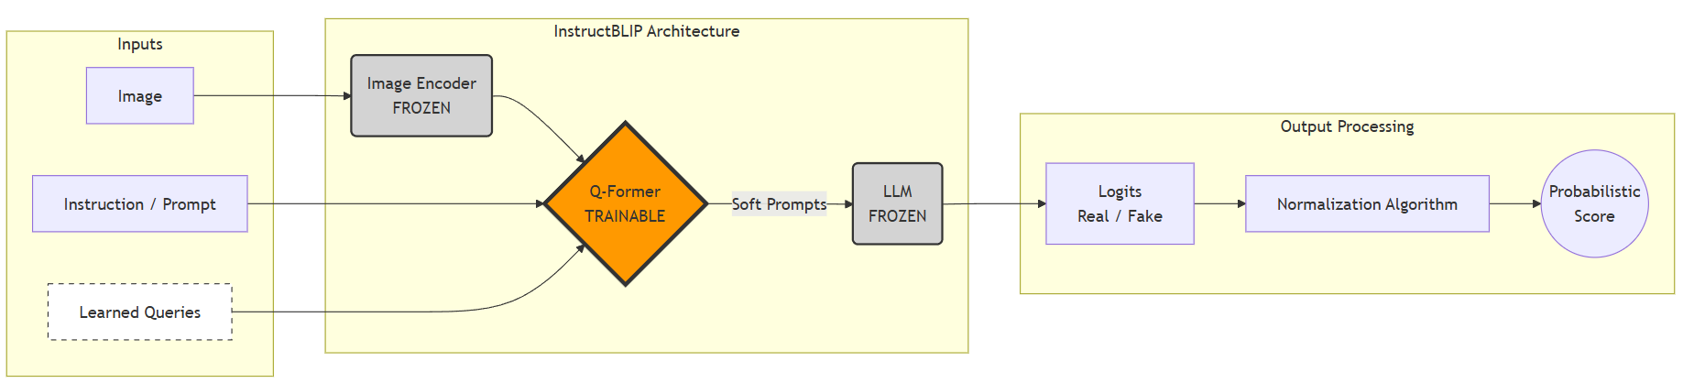
Figure 4: probabilistic inference process using instructBLIP.
The flowchart illustrates the adaptation of the model from text generation to binary deepfake classification. The system receives an image and a close ended query (“is this photo real?”), but instead of decoding an actual textual response, the algorithm directly extracts from the output layer the logits for the tokens “Yes” or “No”. These values are normalized to calculate the probability P(Real | Image), enabling accurate classification based on the model’s pre-trained semantic knowledge (Zero-Shot) without the need for an external classifier.

Training and Fine-tuning Strategy
The research methodology in this project evaluates the system in two configurations: Zero-Shot inference and Few-shot fine tuning. For the training phase, a Parameter-Efficient Fine-Tuning strategy was selected, specifically adapted for large-scale multimodal models.
In InstructBLIP architecture, the Fine-tuning process does not update all model parameters. Instead, the Vision Encoder and the Large Language Model (LLM) components remain “frozen” during training. Weight updates are performed exclusively on the Q-Former component.
This approach was chosen for two primary reasons:
- Prevention of catastrophic forgetting: Freezing the LLM and the Encoder allows the system to retain the contextual knowledge gained during pre-training on millions of images. This prevents the model from losing its general capabilities while adapting to the specific task.
- Computational efficiency & stability: Training only the Q-Former requires significantly less processing power compared to full fine-tuning of a large language model. To further accommodate the 7-billion parameter model on constrained hardware, the system was loaded in bfloat16 precision. This specific format halves the memory footprint while maintaining the dynamic numeric range, preventing underflow issues during training.
The optimization process utilized the AdamW algorithm (with $β_{1}=0.9 and β_{2}=0.999, and a weight decay of 0.05)$to minimize the standard language modeling loss. To maintain numerical stability and prevent the exploding gradient problem during backpropagation, gradient clipping with a maximum norm of 1.0 was strictly applied. To evaluate the model's adaptability, a comparative experimental setup was executed involving two different datasets. First, fine-tuning was conducted on the Celeb-DF-v2 dataset using the default learning rate recommended by the base paper. Using Celeb-DF-v2 ensured the model was trained on high-quality face-swapping manipulations, reflecting realistic security threats. In parallel, the model was trained on the DFDC dataset over three separate runs, each using a different learning rate. This approach allowed us to test how sensitive the model is to hyperparameter changes across different types of data.
For all configurations, a 1:10 train-test data split was used, and training was limited to a single epoch to prevent overfitting.

System Inputs
The system processes two categories of input: visual and textual. The data selection and generation protocols align with the methodologies established by Chen et al. (for the SimSwap algorithm) and Pirogov (the baseline VLM study).

Visual datasets

To comprehensively evaluate the model across different operational phases, including training and cross-dataset generalization, three distinct datasets were utilized:

  - CelebA-HQ (SimSwap Custom Dataset): Constructed strictly for Zero-Shot and Cross-Dataset evaluations. By applying the SimSwap face-swapping algorithm to pristine CelebA-HQ images, a perfectly balanced dataset of 41,712 images (20,856 real, 20,856 fake) was generated. This dataset challenges the system with advanced GAN-based manipulations that retain original facial attributes, providing a clean, high-quality benchmark for evaluating the model's out of distribution generalization capabilities without prior exposure during training.

  - DFDC Train Sample - (Kaggle Extracted Faces Subset): Characterized by diverse, real-world conditions (e.g., poor lighting, varied compression), this specific subset contains pre-extracted facial frames from the original Deepfake Detection Challenge, sourced via Kaggle to optimize the engineering pipeline. This dataset served a dual purpose: it was used for fine-tuning during the comparative hyperparameter sensitivity analysis, and it functioned as a cross-dataset evaluation benchmark for the Celeb-DF-v2 trained model. This allowed for a rigorous evaluation of the model's adaptability across challenging, out-of-distribution data.

  - Celeb-DF-V2: A large-scale, high-quality dataset containing thousands of manipulated celebrity videos generated with advanced algorithms to minimize visual artifacts. Specifically designed to test the robustness of detection systems against highly realistic deepfakes, this dataset served a dual purpose: it was utilized for the primary fine-tuning phase and acted as a rigorous cross-dataset evaluation benchmark for models trained on DFDC. Frames were uniformly sampled from the videos (32 frames per video, totaling 159,968 images) to train the Q-Former to recognize high-fidelity semantic anomalies.

Prompt Design

Following the methodology established by Pirogov (2025), the system’s performance is highly sensitive to the chosen prompt format. Empirical analysis revealed that a minimal, direct instruction yields the most robust results for the InstructBLIP architecture. Consequently, the selected prompt is: “is this photo real?” This concise, binary-focused instruction serves two critical functions:

- Semantic Priming: It directs the VLM's attention towards a binary state-authentication vs. forgery, thereby minimizing redundant or descriptive output that could introduce noise into the classification.
- Alignment with Probabilistic Inference: This prompt forces the model to distribute its probability mass primarily between the target tokens “Yes” (for real) and “No” (for fake). This distribution is essential for our probabilistic inference pipeline (Section 3.2), as it allows for the precise extraction of logits and the calculation of a continuous confidence score, which is fundamental for computing performance metrics like AUC and EER.

Results and Evaluation

System Implementation Overview

Two independent detection systems were implemented and evaluated in this study.

InstructBLIP system. The datasets (CelebA-HQ, DFDC, Celeb-DF-v2) were prepared and stored on Google Drive in advance CelebA-HQ was generated by applying the SimSwap face-swapping algorithm to pristine CelebA-HQ images, while Celeb-DF-v2 frames were extracted from source videos and processed via RetinaFace. Each experimental run was then executed as a standalone Colab pipeline consisting of five independent stages: (1) installing dependencies; (2) importing the relevant dataset from Drive; (3) initializing the model - loading the InstructBLIP base weights and, depending on the experiment (Zero-Shot, Fine-Tuning, or Evaluation of a previously fine-tuned checkpoint), loading the corresponding Q-Former weight set; (4) loading the selected dataset into the dataloader; and (5) running the model - either a fine-tuning loop that updates only the Q-Former, or a combined evaluation loop. The model-initialization stage and the dataset-loading stage are independent of one another, allowing any dataset to be evaluated under any model configuration. The evaluation loop processes the test set batch by batch and performs two operations jointly for each batch: first, the pooled Q-Former hidden states are extracted and stored as embeddings for the downstream t-SNE and Silhouette Score analysis; second, a constrained single-token generation step is run, from which the Yes/No logits are extracted, de-duplicated across tokenizer variants, reduced via MAX per class, and normalized through Softmax to obtain P(Fake) for each image. The resulting probabilities, true labels, and embeddings are saved to Drive, after which ROC-AUC is computed, an optimal threshold is selected via an iterative search over [0.10, 0.90], and Accuracy, F1, Precision, and Recall are calculated at that threshold - followed by a separate plotting stage producing the ROC curves, confusion matrices, probability distributions, and t-SNE visualizations.

SBI system. The implementation is similarly organized into a Preprocessing module, responsible for face detection (RetinaFace), cropping, and resizing to 380×380; a Detector module, consisting of the pretrained EfficientNet-B4 classifier loaded with either the FFraw or FFc23 weight set; and an Aggregation/Evaluation module, which converts per-face fake probabilities into video-level (Celeb-DF-v2) or image-level (CelebA-HQ, DFDC) predictions and computes the corresponding metrics. The execution flow proceeds as follows: the pretrained weights are loaded into the detector and set to evaluation mode; for Celeb-DF-v2, the official inference script samples 32 frames per video, detects and crops faces, and aggregates per-frame scores into a video-level prediction (maximum per frame, averaged across frames); for CelebA-HQ and DFDC, a custom image-loop pipeline performs the same detection-and-crop procedure per image, using the maximum score across detected faces and skipping images with no valid detection; the resulting scores are then used to compute ROC-AUC, threshold-based accuracy, and average fake scores per class.

Both systems were evaluated using the same downstream methodology, detailed in the following section.

Unit Testing and Validation
To ensure the correctness of both detection pipelines prior to large-scale evaluation, a dedicated unit testing suite was implemented for each system using pytest.
For the InstructBLIP system, tests were organized into three categories. Module-level tests verified that the processor and model load correctly with the expected Q-Former, vision encoder, and query-token components; that input images are correctly converted into the tensor format required by the model; and that the model produces a non-empty textual response when prompted. The Probabilistic Inference Algorithm itself was validated independently of the model: tests confirmed that the SoftMax normalization over the {Yes, No} token subset always returns a valid probability in [0, 1] and that P(Real) + P(Fake) sums to 1, including under negative logits and extreme logit gaps - explicitly verifying the design choice of SoftMax normalization over raw division, which can produce invalid values when logits are negative. Additional tests confirmed that the de-duplication of tokenizer variants (e.g., "Yes" / " Yes") produces non-overlapping Yes/No token ID sets, and that the system raises an explicit error rather than failing silently if such an overlap were to occur. Data pipeline tests verified correct label encoding ("No" → Fake, "Yes" → Real), correct handling of grayscale-to-RGB conversion, and robustness to unusually small input images. System integration tests validated the full inference pipeline end-to-end: that output scores remain within [0, 1] on both blank and synthetically blended inputs, that inference is fully deterministic across repeated runs on the same image, that batched inference produces one valid score per image, and that the extracted Q-Former embeddings used for the t-SNE analysis have the expected shape. All InstructBLIP unit tests passed successfully.
For the SBI system, unit tests focused on the geometric and arithmetic correctness of the synthetic data generation pipeline described in Section 2.2: that source images load and convert to RGB correctly, that facial landmark coordinates fall within valid image bounds, that the convex-hull blending mask is non-trivial (neither empty nor fully saturated) and bounded in [0, 1], and that the core blending operation - combining the source and target images according to the per-pixel mask weights - preserves valid pixel ranges, produces an output that differs from both source and target images, and matches the expected result on known input values.

Evaluation Methodology
The evaluation of the fine-tuned InstructBLIP model was conducted through a structured pipeline applied consistently across all datasets and weight configurations. For each input image, the pipeline proceeds as follows: the image is first passed through the frozen Vision Encoder and Q-Former to extract deep visual features; the Q-Former embeddings are then pooled and stored for downstream representation analysis; finally, the model performs a constrained generation step.
To obtain a continuous anomaly score, we utilize the Probabilistic Inference Algorithm detailed in Section 3.2. By restricting the generation step and applying SoftMax normalization over the maximum logits of the target variants, we derive a calibrated probability score, $P(Fake∣x)$, for each image.
The optimal classification threshold is not fixed as a preset. Instead, we perform an iterative threshold search over the range [0.10, 0.90] in steps of 0.01, selecting the threshold that maximizes accuracy on the test set. This deliberate approach allows the model's decision boundary to adapt to the specific data distributions and class imbalances encountered across different datasets.
The primary evaluation metrics utilized are:
- ROC-AUC: Measures the model's discriminative capability independently of any threshold, serving as the principal metric for assessing structural representation and comparison across methods.
- Accuracy (ACC): Computed at the optimal threshold identified during the iterative search.
- F1, Precision, and Recall: Provide a comprehensive picture of the classification behavior, balancing False Acceptance and False Rejection, which is particularly important given class imbalances in certain test sets (e.g., DFDC).
- Equal Error Rate (EER): The point at which the False Acceptance Rate equals the False Rejection Rate; a standard industry metric in biometric and liveness detection systems (achieving 0.0666 on the DFDC Fine-Tuned configuration).
- Bootstrap 95% Confidence Interval on AUC: Computed over 1,000 resampled iterations, providing statistical reliability bounds on the reported AUC values.
In addition to the standard classification metrics, we incorporate two structural analysis dimensions that go beyond the base paper:
- Q-Former Embedding Visualization (t-SNE + Silhouette Score): The Q-Former's output embeddings are extracted and projected to 2D space using t-SNE, while the Silhouette Score quantifies cluster separation between Real and Fake samples. This analysis reveals that the model's classification capability is driven primarily by the terminal logit layer rather than by spatially separable internal representations - an insight into the fundamental operating mechanism of VLMs applied to deepfake detection, consistent with the architecture's design as a language-guided discriminator.
- Probability Distribution Analysis: The distribution of $P(Fake∣x)$scores are plotted separately for Real and Fake samples, visualizing the model's confidence and the mathematical sharpness of its decision boundaries.

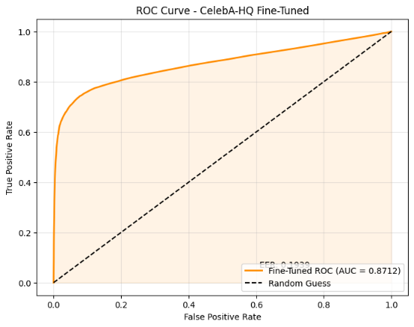
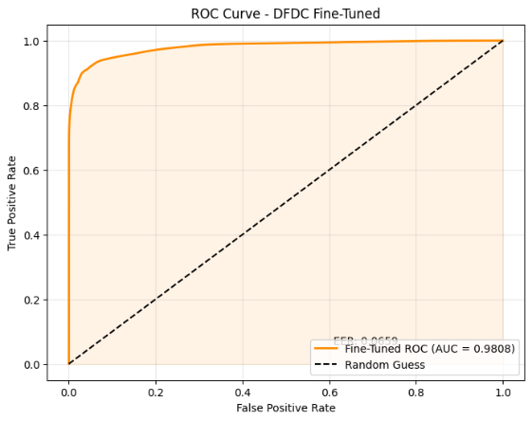
InstructBLIP Results
Figure 5: ROC Curves - DFDC Fine-Tuned (AUC=0.9808) and CelebA-HQ Cross-Dataset (AUC=0.8712), presented side by side. The contrast between the two curves illustrates the gap between in-domain performance and cross-dataset generalization capability.
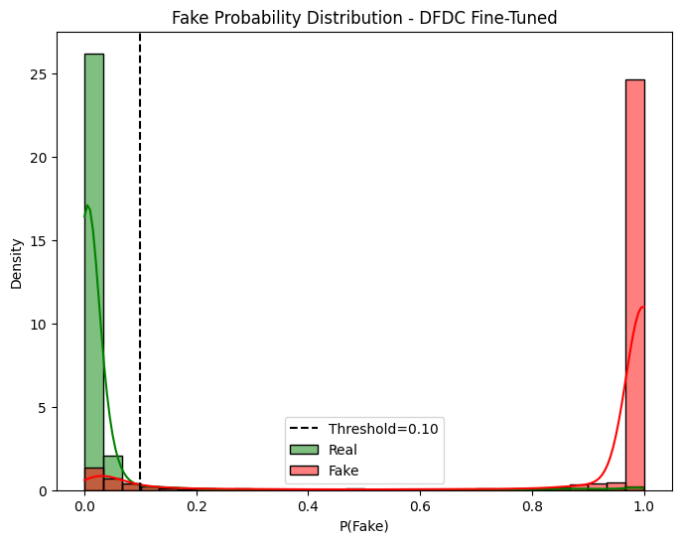
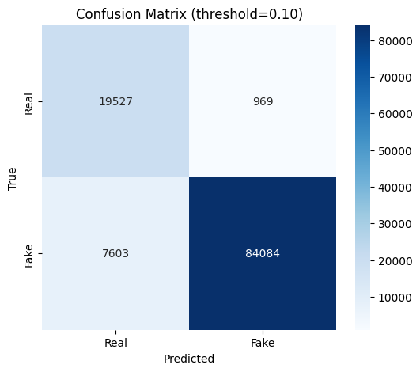
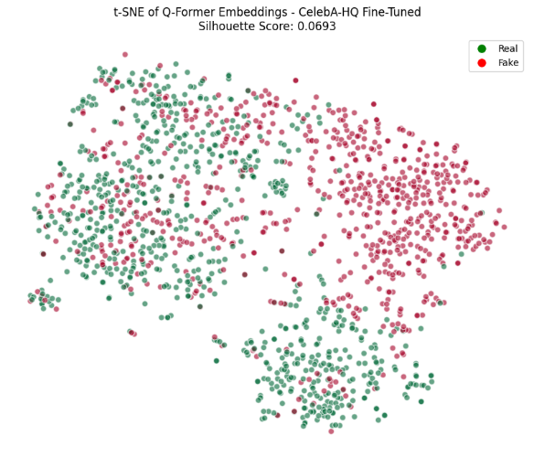
Figure 6: DFDC Fine-Tuned model outputs. Left: Confusion Matrix at threshold=0.10 - the natural class imbalance is effectively handled by the dynamic threshold selection mechanism. Right: Fake Probability Distribution - the distinct bimodal distribution, with Real samples concentrated near P=0 and Fake samples near P=1, demonstrate strong model confidence and effective class separation after fine-tuning.

Figure 7: t-SNE of Q-Former Embeddings - DFDC weights evaluated on CelebA-HQ (Silhouette Score: 0.0693). The mixed clustering pattern reveals that InstructBLIP's generalization mechanism operates at the logit level rather than through spatially separable feature representations - a structural insight into how VLMs perform cross-domain deepfake detection


Figure 8: Qualitative examples from the CelebA-HQ (SimSwap) evaluation using the DFDC Fine-Tuned model. Left to right: three correctly classified fake images (59.3%, 79.8%, 99.9%), two misclassified fakes assigned low fake probability (2.9%, 2.0%), and one misclassified real image assigned elevated fake probability (32.1%), illustrating the model's sensitivity to high-quality GAN-based manipulations.
Table 1: InstructBlip Evaluation results
Model Configuration | Test Dataset (Evaluation) | Eval Type | ROC-AUC (95% CI) | Accuracy  (%) | Optimal Threshold | F1 Score | Silhouette Score
Zero-Shot (Base) | CelebA-HQ (SimSwap) | Cross-Domain | 0.7406 [0.73, 0.74] | 73.76 | 0.3 | 0.669 | 0.0496
Zero-Shot (Base) | Celeb-DF-v2 | Cross-Domain | 0.5564 [0.55, 0.56] | 92.37 | 0.1 | 0.9603 | 0.0284
Zero-Shot (Base) | DFDC | Cross-Domain | 0.5334 [0.52, 0.53] | 79.05 | 0.1 | 0.8821 | 0.0249
Fine-Tuned (Celeb-DF-v2) | Celeb-DF-v2 | In-Domain | 0.9004 [0.89, 0.90] | 86.63 | 0.1 | 0.9236 | 0.2136
Fine-Tuned (Celeb-DF-v2) | CelebA-HQ (SimSwap) | Cross-Domain | 0.7654 [0.76, 0.77] | 70.94 | 0.33 | 0.6737 | 0.0853
Fine-Tuned (Celeb-DF-v2) | DFDC | Cross-Domain | 0.5593 [0.55, 0.56] | 35.50 | 0.1 | 0.3891 | 0.0194
Fine-Tuned (DFDC, LR=5e-5) | DFDC | In-Domain | 0.9808 [0.98, 0.98] | 92.36 | 0.1 | 0.9515 | 0.1285
Fine-Tuned (DFDC, LR=5e-5) | CelebA-HQ (SimSwap) | Cross-Domain | 0.8712 [0.86, 0.87] | 83.26 | 0.23 | 0.816 | 0.0693
Fine-Tuned (DFDC, LR=5e-5) | Celeb-DF-v2 | Cross-Domain | 0.6682 [0.66, 0.67] | 82.16 | 0.1 | 0.8994 | 0.0337
Fine-Tuned (DFDC, LR=1e-4) | DFDC | In-Domain | 0.9814 [0.98, 0.98] | 94.50 | 0.26 | 0.9660 | 0.5731
Fine-Tuned (DFDC, LR=1e-4) | CelebA-HQ (SimSwap) | Cross-Domain | 0.7453 [0.74, 0.75] | 68.90 | 0.88 | 0.6414 | 0.0923
Fine-Tuned (DFDC, LR=1e-4) | Celeb-DF-v2 | Cross-Domain | 0.6727 [0.67, 0.68] | 92.61 | 0.10 | 0.9616 | 0.2165
Fine-Tuned (DFDC, LR=1e-4) | DFDC | In-Domain | 0.9814 [0.98, 0.98] | 94.50 | 0.26 | 0.9660 | 0.5731
Fine-Tuned (DFDC, LR=1e-5) | DFDC | In-Domain | 0.8791 [0.88, 0.88] | 85.19 | 0.21 | 0.9113 | 0.0302
Fine-Tuned (DFDC, LR=1e-5) | CelebA-HQ (SimSwap) | Cross-Domain | 0.8074 [0.80, 0.81] | 77.46 | 0.11 | 0.7348 | 0.0478
Fine-Tuned (DFDC, LR=1e-5) | Celeb-DF-v2 | Cross-Domain | 0.5415 [0.54, 0.55] | 31.36 | 0.10 | 0.4276 | 0.0299

The experimental results presented in Section 4.2 demonstrate a clear and consistent pattern that both validates and qualifies the core hypothesis of this research, while revealing important structural insights into how VLMs perform deepfake detection.
Zero-Shot Generalization. The base InstructBLIP model, without any fine-tuning, achieved an AUC of 0.7406 on the CelebA-HQ (SimSwap) dataset - a meaningful result given that it was obtained with no prior exposure to deepfake data, relying solely on semantic knowledge acquired during pre-training. However, on Celeb-DF-v2 and DFDC, the Zero-Shot configuration yielded AUC values of 0.5564 and 0.5334 respectively, which are statistically equivalent to random chance. This inconsistency suggests that Zero-Shot performance is not universal but rather dataset-dependent: CelebA-HQ, as a well-known high-quality celebrity face dataset, is likely well-represented in the large-scale pre-training corpora of InstructBLIP, making its visual domain familiar to the model's frozen encoders. In contrast, DFDC and Celeb-DF-v2 contain video-extracted frames under diverse real-world conditions that may be underrepresented in that pre-training distribution.
Few Shot Adaptation and Cross-Dataset Generalization. The most significant finding of this research is the performance achieved following minimal Q-Former fine-tuning. The DFDC-trained model (LR=5e-5) achieved an in-domain AUC of 0.9808, and critically, maintained strong cross-dataset performance of AUC=0.8712 on CelebA-HQ - a dataset the model was never trained on. This cross-dataset result represents the central contribution of this work: with only a lightweight fine-tuning of the Q-Former component, the model achieves robust generalization to unseen forgery types, substantially outperforming the Zero-Shot baseline and demonstrating that VLMs can serve as practical, adaptable deepfake detectors without full retraining.
Domain Gap and Cross-Dataset Limitations. The most notable underperformance was observed when the model fine-tuned on Celeb-DF-v2 was evaluated on DFDC (AUC=0.5593). This result reflects a fundamental domain gap: Celeb-DF-v2 consists of clean, high-quality, controlled recordings, while DFDC contains real-world conditions such as varied compression, poor lighting, and background noise. The model overfitted to the clean domain's artifact distribution and failed to generalize to out-of-distribution real-world conditions - a well-documented limitation in cross-dataset deepfake detection.
Structural Insight: Logit-Level Discrimination. The t-SNE visualizations of Q-Former embeddings consistently showed low Silhouette Scores across all configurations (ranging from 0.0249 to 0.2136), indicating that Real and Fake samples are not linearly separable in the embedding space. Rather than representing failure, this finding reveals a fundamental characteristic of how VLMs operate: classification decisions are formed at the terminal logit layer through language-guided reasoning, not through spatially separable feature representations. This is consistent with the model's design - the frozen pre-trained representations are preserved intact, confirming that the PEFT strategy successfully prevented catastrophic forgetting while enabling task specific adaptation at the decision layer.

4.5 SBI Baseline - Implementation & Results
Overview and Purpose: In addition to the InstructBLIP-based evaluation described in the previous sections, this project also examined the performance of Self-Blended Images (SBI) as a traditional deepfake detection baseline. The purpose of this evaluation was to compare a dedicated binary deepfake detector against the Vision-Language Model approach and to better understand the practical limitations of artifact-based detectors under cross-dataset conditions.
The SBI experiments were designed around two pretrained weight configurations and three evaluation datasets. The two pretrained weight sets were FFraw and FFc23, both trained on Self-Blended Images generated from FaceForensics++ data. The three datasets were Celeb-DF-v2, the custom CelebA-HQ Balanced dataset generated using SimSwap, and a DFDC validation subset obtained from Kaggle. This produced six total experiments: FFraw and FFc23 were each evaluated on all three datasets.
The main objective was not only to measure classification performance, but also to examine whether SBI remains reliable when the evaluation data differs from its original training distribution. This is important because deepfake detectors frequently achieve strong performance on familiar datasets while degrading significantly when applied to unseen manipulation methods, different image qualities, or different preprocessing conditions.
SBI Model and Pretrained Weights: Self-Blended Images is a deepfake detection method that generates synthetic fake samples by blending transformed versions of the same source face. Instead of relying on pairs of different identities, SBI creates artificial blending artifacts from a single real face image. This encourages the detector to learn generic visual inconsistencies such as blending boundaries, local color differences, and frequency-level distortions.
In the repository used in this project, SBI is implemented as an EfficientNet-B4 binary classifier. During inference, the model receives a cropped face image and outputs class logits for the Real and Fake classes. These logits are converted into a fake probability score using SoftMax, and the score associated with the Fake class is used as the detector output.
Two official pretrained weight sets were evaluated:
- FFraw represents a detector trained using SBI samples generated from raw FaceForensics++ data. This setting is useful for evaluating performance when the training domain contains high-quality, minimally compressed facial content.
- FFc23 represents a detector trained using SBI samples generated from the compressed c23 version of FaceForensics++. This setting is important because real-world media often undergoes compression before reaching detection systems. Evaluating both FFraw and FFc23 therefore provides insight into whether training on raw or compressed data leads to better generalization across the selected datasets.
For each evaluation, the relevant pretrained SBI weights (FFraw or FFc23) were loaded into the EfficientNet-B4 backbone and set to evaluation mode. For Celeb-DF-v2, predictions were produced at the video level: faces were sampled across multiple frames per video, and the per-frame fake probabilities were aggregated (by maximum score per frame, averaged across frames) into a single video-level score, in line with the official SBI evaluation protocol. For CelebA-HQ Balanced and DFDC, which consist of individual images rather than videos, predictions were produced at the image level: each image was processed for face detection, and the resulting fake probability was used directly as the image-level score, with multi-face images resolved by taking the maximum detected fake probability. In all cases, the resulting probability scores were used to compute ROC-AUC, threshold-based accuracy, and average fake scores for the real and fake classes, following the same evaluation methodology described in Section 4.1.
Experimental Observations: Results followed a clear hierarchy across datasets. On Celeb-DF-v2, both weight sets performed strongly (FFraw: 0.9385, FFc23: 0.9292), consistent with domain alignment. On CelebA-HQ (SimSwap), performance remained meaningful (0.8393 / 0.8338) but score calibration was weaker - real images frequently received elevated fake probabilities, requiring a threshold of ~0.89–0.90. On DFDC, both configurations approached chance level (≈0.595), reflecting the domain gap and compounded by the preprocessing failures described in Section 4.6..
Table 2: SBI Experimental results
Weight Set | Test  Dataset (Evaluation) | Eval Type | Evaluation Units | ROC-AUC (95% CI) | Accuracy  (%) | Avg Fake Score  on Fake | Avg Fake score  on Real
FFc23 | Celeb-DF-v2 | Cross-Dataset | 518 videos | 0.9292 [0.9076, 0.9491] | 85.91% | Not reported | Not reported
FFraw | Celeb-DF-v2 | Cross-Dataset | 518 videos | 0.9385 [0.9179, 0.9569] | 86.68% | Not reported | Not reported
FFc23 | CelebA-HQ Balanced/SimSwap | Cross-Dataset | 41,629 images | 0.8338 [0.8299, 0.8377] | 75.45% | 0.9388 | 0.7437
FFraw | CelebA-HQ Balanced/SimSwap | Cross-Dataset | 41,629 images | 0.8393 [0.8356, 0.8430] | 76.19% | 0.9222 | 0.6997
FFc23 | DFDC | Cross-Dataset | 24,247 images | 0.5949 [0.5870, 0.6029] | 76.05% | 0.3293 | 0.2557
FFraw | DFDC | Cross-Dataset | 24,247 images | 0.5959 [0.5880, 0.6038] | 77.06% | 0.3624 | 0.2948

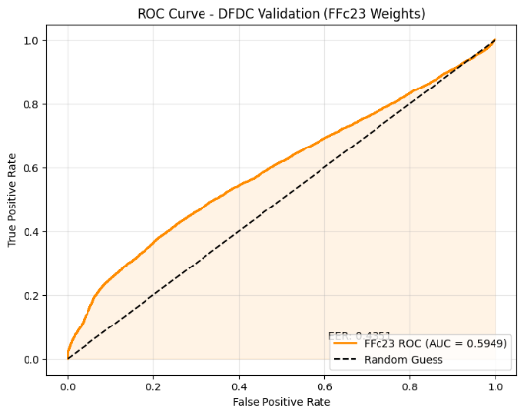
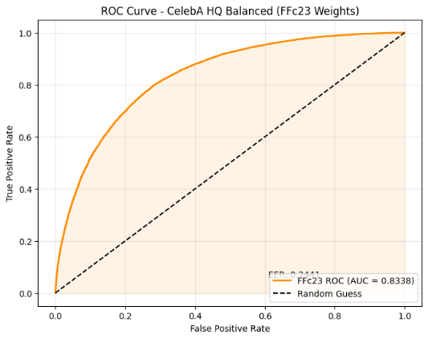
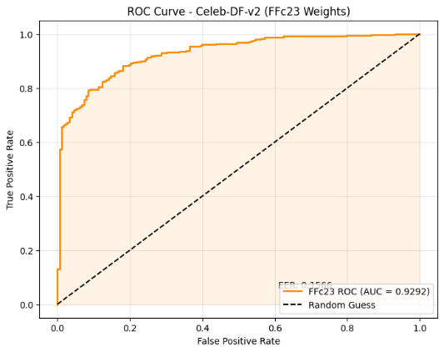
The DFDC + FFc23 result is especially important. The FFc23 weights trained on FaceForensics++ showed limited generalization to DFDC, with AUC = 0.5949. This is consistent with the known cross-dataset generalization problem in deepfake detection. At the same time, the average fake score on fake images was higher than on real images, which means the model was not entirely random. It retained a weak discriminative signal, but the signal was insufficient for robust deployment-level classification.

Figure 9: ROC Curves - SBI with FFc23 weights evaluated on all three datasets. The three curves show a clear performance hierarchy: strong detection on Celeb-DF-v2 (AUC=0.9292), meaningful but weaker cross-dataset performance on CelebA-HQ Balanced (AUC=0.8338), and limited generalization to DFDC (AUC=0.5949). This contrast illustrates the sensitivity of traditional artifact-based detectors to dataset distribution and image quality.
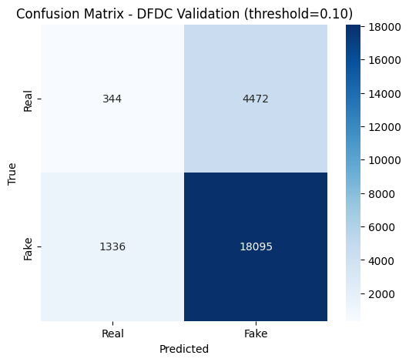
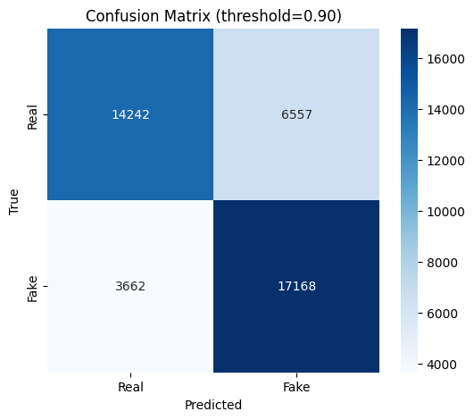
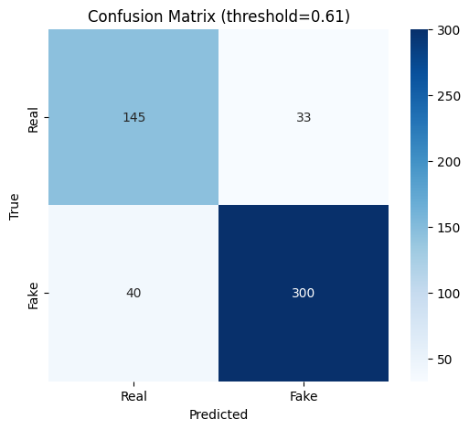
Figure 10: Confusion Matrices - SBI with FFc23 weights across the three evaluation datasets. Celeb-DF-v2 achieves strong classification performance at threshold=0.61, while CelebA-HQ Balanced requires a much higher threshold=0.90 due to elevated fake probabilities among real samples. DFDC uses a low threshold=0.10, reflecting the weak score separation and the effect of dataset imbalance. These matrices demonstrate that SBI performance depends strongly on threshold calibration across domains.
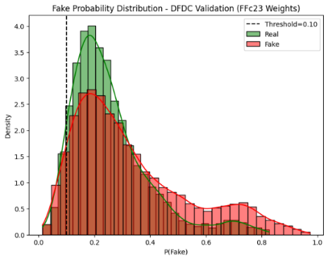
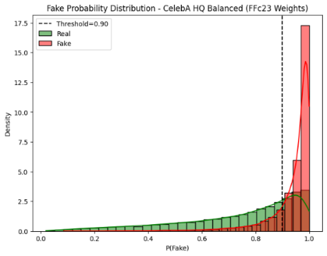
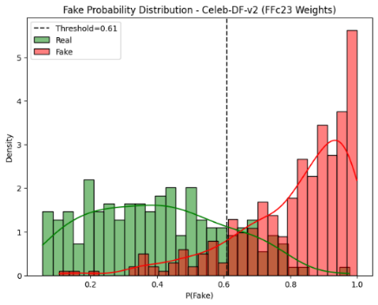
Figure 11: Fake Probability Distributions - SBI with FFc23 weights evaluated on Celeb-DF-v2, CelebA-HQ Balanced / SimSwap, and DFDC. Celeb-DF-v2 shows the clearest separation between real and fake samples, while CelebA-HQ Balanced shows partial overlap and high fake probabilities for many real images, indicating weaker calibration. DFDC shows substantial overlap between the two distributions, with fake images receiving only slightly higher average scores than real images, supporting the conclusion that SBI captures a weak discriminative signal but generalizes poorly to this dataset.
Overall Assessment: The SBI evaluation shows that SBI is a strong traditional deepfake detection baseline when the test data is relatively aligned with its FaceForensics++ training domain. The best results were achieved on Celeb-DF-v2, with AUC values of 0.9385 using FFraw and 0.9292 using FFc23. On the custom CelebA-HQ Balanced dataset generated with SimSwap, SBI still demonstrated meaningful cross-dataset detection ability, reaching AUC values of 0.8393 and 0.8338. However, the high fake scores assigned to some real images indicate weaker calibration under this more challenging dataset.
The weakest results were obtained on DFDC, where both weight sets achieved an AUC of approximately 0.59. This suggests limited generalization to the DFDC domain, especially considering the large number of failed face detections and invalid crops during preprocessing. Overall, SBI performs well on aligned datasets and moderately well on the SimSwap-based dataset, but its performance decreases significantly under stronger domain shift. These findings support the project’s motivation for comparing SBI with VLM-based approaches such as InstructBLIP.

4.6 Comparative Analysis: VLM vs. Traditional Detector
A direct comparison between the InstructBLIP-based system and the SBI baseline, evaluated across the same three datasets, provides the clearest test of the project's central hypothesis: that a Vision-Language Model's semantic understanding can outperform a traditional, artifact-based detector in cross-domain conditions.
On Celeb-DF-v2, SBI remains the stronger detector. Both pretrained configurations achieved high in-domain-aligned performance (AUC=0.9385 for FFraw, 0.9292 for FFc23), exceeding even the best InstructBLIP result on this dataset, the in-domain fine-tuned configuration (AUC=0.9004). This is expected: Celeb-DF-v2 is closely aligned with the controlled, high-quality manipulation style that SBI was designed and benchmarked on, giving the traditional detector a clear domain advantage here.
The picture changes substantially on CelebA-HQ (SimSwap) - a dataset neither detector was trained on, making this the fairest cross-dataset comparison in the study. Here, the fine-tuned InstructBLIP configuration (DFDC, LR=5e-5) achieved an AUC of 0.8712, surpassing both SBI configurations (0.8393 for FFraw, 0.8338 for FFc23) despite having no prior exposure to SimSwap-generated forgeries. This result is the central empirical support for the project's hypothesis: with only a lightweight Q-Former fine-tuning step, the VLM generalized to an unseen, high-fidelity manipulation method more effectively than a dedicated, fully trained binary classifier.
On DFDC, both detectors struggled. SBI's cross-dataset performance (AUC≈0.595 for both weight sets) and InstructBLIP's Zero-Shot performance (AUC=0.5334) were both close to chance level. As discussed in Section 4.2, this is consistent with the conclusion that DFDC's real-world recording conditions are likely underrepresented in both the SBI training distribution and InstructBLIP's pre-training corpus, making this dataset a shared point of weakness rather than a differentiator between the two approaches.
Taken together, these results qualify rather than unconditionally confirm the project's hypothesis: VLM-based detection does not outperform a traditional detector universally, but it does demonstrate a clear advantage specifically in the cross-dataset generalization scenario the project set out to address - and does so with substantially less task-specific training than a fully supervised binary classifier requires.

4.7 Challenges, Key Decisions and Lessons Learned
This section describes the main engineering challenges we faced during Phase B, the decisions we made to deal with them, and what we would do differently if we started the project again.
Dataset Selection and Training Order: The first fine-tuning phase was done on Celeb-DF-v2, based on the assumption that its high-quality, realistic manipulations would help the model learn more subtle forgery artifacts. However, the resulting performance showed only a small improvement over the Zero-Shot baseline, especially in cross-dataset scenarios (AUC=0.5593 on DFDC). This result led us to run an additional training phase on DFDC, which gave much stronger results both in-domain and cross-dataset. In hindsight, DFDC should have been the primary training dataset from the start, since it has more diversity and reflects real-world conditions better than Celeb-DF-v2.
Learning Rate Optimization: Instead of using an automated learning-rate scheduler, we manually compared three learning rates on the DFDC dataset. The first results suggested the model was converging too fast, which raised concerns about overfitting. Lowering the learning rate confirmed this - performance improved. We selected an intermediate value (LR=5e-5) that balanced convergence speed with generalization, and it produced our best overall results (AUC=0.9808 in-domain, AUC=0.8712 cross-dataset). This manual comparison gave us direct evidence of how sensitive the Q-Former fine-tuning process is to the learning rate.
Probabilistic Inference Design: A key engineering decision in the inference pipeline was to use MAX logit extraction across token variants instead of averaging them. Since the model's tokenizer maps the same word to several token IDs depending on formatting (e.g., "Yes", "yes", " Yes"), the algorithm takes the maximum logit value within each class subset - the strongest positive signal - rather than averaging across all variants, which could dilute the model's real confidence. The final probability is then computed with Softmax over the {Yes, No} pair. The rest of the training hyperparameters (AdamW with β₁=0.9, β₂=0.999, weight decay=0.05, gradient clipping at max norm=1.0, single-epoch training) were taken directly from the base paper.
Dataset Generation Pipeline: The CelebA-HQ dataset was built by first scanning all source images and generating a JSON index of valid candidates for high-quality face-swapping with SimSwap. During the first generation run we found a pipeline error, fixed it, and regenerated the dataset to make sure the final balanced set of 41,712 images was correct.
Infrastructure and Preprocessing Constraints: All experiments ran on Google Colab, which created two separate practical problems. First, the 7-billion parameter InstructBLIP model had to be loaded in bfloat16 precision to fit in the available GPU memory - this halved the memory footprint while keeping enough dynamic range to avoid underflow during backpropagation. Second, after RetinaFace-based face cropping produced a large number of individual image files for Celeb-DF-v2, creating one consolidated ZIP archive turned out to be infeasible - the process kept exceeding Colab session limits and crashed several times over two days. Because of this, cropped frames were transferred directly from Google Drive to the Colab runtime as raw files instead, which was slower given the size of the dataset. To reduce the number of these transfers, we combined several experimental stages (for example fine-tuning and evaluation) into single notebooks instead of running them as separate pipelines. This changed how the project was executed but did not affect the model's behavior or the results themselves.
Preprocessing Sensitivity: RetinaFace-based face detection turned out to be sensitive to real-world recording conditions. On the DFDC dataset specifically, 6,547 out of 30,794 images (over 21%) were skipped because the face-detection step failed to find a valid facial region - a much higher failure rate than on CelebA-HQ or Celeb-DF-v2. This affected the SBI evaluation directly, since its pipeline depends on RetinaFace for cropping, and it means the effective SBI test set on DFDC is a filtered subset that disproportionally excludes low-quality or challenging images, which likely makes the reported AUC look a bit better than true deployment performance would be.
Threshold Sensitivity: Both detectors needed dataset-specific threshold calibration instead of a single fixed value - the optimal threshold ranged from 0.10 to 0.88 across the InstructBLIP configurations, and from 0.10 to 0.90 for SBI. This shows that a fixed decision boundary (like the default 0.5) is not a reliable choice for deepfake detection in general, no matter which architecture is used, and that any real deployment of either approach needs a calibration step against representative validation data.
Overall, we think the project execution was reasonable, and most of the key decisions were justified by the results we got. The main thing we would change in hindsight is the dataset order - starting with DFDC instead of Celeb-DF-v2 would have saved time and reached the strong results earlier in the project.

4.8 Project Goals Assessment
The primary goal of this project, as defined in Phase A, was to evaluate whether Visual Language Models - specifically InstructBLIP - can overcome the generalization limitations of traditional binary classifiers in deepfake detection, operating effectively in Zero-Shot and Few-Shot scenarios. Two reference benchmarks were established: the Zero-Shot performance of InstructBLIP as reported in the base paper (Pirogov, 2025), and the SBI detector as the principal trained baseline to surpass.
Zero-Shot Performance: The base paper reports an AUC of 0.813 for InstructBLIP in Zero-Shot mode on the CelebA-HQ dataset. Our Zero-Shot implementation achieved an AUC of 0.7406 on the same dataset type, falling slightly below this reference value. This gap is attributable to a methodological difference: while Pirogov (2025) used simple probability summation across token variants, our implementation uses MAX logit extraction - a deliberate engineering decision that prioritizes numerical stability over raw score magnitude. On DFDC and Celeb-DF-v2, Zero-Shot performance was near-random (AUC ≈ 0.55), consistent with the base paper's findings that Zero-Shot generalization is dataset-dependent and not universal.
Few-Shot Adaptation: The base paper reports near-perfect performance following Q-Former fine-tuning on DFDC with LR=1e-4. Our best configuration (LR=5e-5) achieved AUC=0.9808 in-domain - matching this benchmark - while also demonstrating strong cross-dataset generalization to CelebA-HQ (AUC=0.8712), a result that was not evaluated in the base paper and represents an original contribution of this work.
Performance Relative to the SBI Baseline: As shown in the comparison in Section 4.6, the fine-tuned InstructBLIP system did not outperform SBI in every case, but it did meet the specific goal that the SBI benchmark was meant to test: outperforming a dedicated, fully trained detector on a manipulation type it never saw before. On CelebA-HQ (SimSwap), fine-tuned InstructBLIP (AUC=0.8712) exceeded both SBI configurations, while on Celeb-DF-v2, SBI remained stronger on its own aligned domain. This confirms that the VLM's advantage is specific to cross-domain generalization, not a general superiority over SBI.
Evaluation Rigor: Beyond raw AUC, the project goal included producing decision-grade, deployment-relevant metrics rather than a single discriminability score. This was achieved through the Equal Error Rate (EER=0.0666 on the DFDC Fine-Tuned configuration), Bootstrap 95% confidence intervals on all reported AUC values, and an iterative threshold search per dataset rather than a fixed cutoff. These additions, which go beyond what is reported in the base paper, support the goal of evaluating the system under conditions relevant to practical biometric and liveness-detection use cases, not only as an academic discriminability benchmark.
Overall Assessment: The project goals were substantially met: the Few-Shot configuration matched state-of-the-art in-domain performance, demonstrated meaningful cross-dataset generalization that surpassed the SBI baseline on an unseen manipulation method, and confirmed the central hypothesis that lightweight Q-Former fine-tuning is sufficient for effective deepfake detection. The Zero-Shot results, while dataset-dependent, are consistent with the literature and provide valuable insight into the conditions under which VLMs succeed and fail as zero-shot detectors.
Configuration | Dataset | AUC
Pirogov (2025) - Zero-Shot | CelebA-HQ | 0.813
Ours - Zero-Shot | CelebA-HQ | 0.7406
Pirogov (2025) - Fine-Tuned | DFDC | ~0.98
Ours - Fine-Tuned (LR=5e-5) | DFDC | 0.9808
Ours - Fine-Tuned (LR=5e-5) | CelebA-HQ (cross) | 0.8712
SBI- FFraw X | CelebA-HQ (cross) | 0.8393
SBI- FF23 | CelebA-HQ (cross) | 0.8338

Conclusion and Future Work
This project sets out to answer a concrete research question: can a Vision-Language Model, adapted through lightweight fine-tuning, overcome the generalization limitations that constrain traditional deepfake detectors? The results provide a qualified but meaningful affirmative answer.
The InstructBLIP-based system, fine-tuned exclusively on the Q-Former component using the DFDC dataset, achieved an in-domain AUC of 0.9808 - matching state-of-the-art benchmarks reported in the literature - while simultaneously generalizing to a completely unseen manipulation method (SimSwap-generated CelebA-HQ), reaching AUC=0.8712 and surpassing the dedicated SBI baseline (AUC=0.8393 / 0.8338) on that same cross-domain evaluation. This cross-dataset result is the central empirical contribution of this work: a single lightweight fine-tuning step, updating fewer than 5% of the model's parameters, was sufficient to produce a detector that generalizes more effectively than a fully supervised binary classifier trained specifically for deepfake detection.
At the same time, the results qualify the hypothesis rather than confirm it universally. On in-domain-aligned data (Celeb-DF-v2), SBI retained a clear advantage, and on DFDC under Zero-Shot conditions, InstructBLIP performed near chance level - revealing that VLM-based detection is dataset-dependent, not universally superior. The structural analysis (t-SNE, Silhouette Score) further revealed that classification is driven at the terminal logit layer through language-guided reasoning rather than through linearly separable feature representations, offering insight into the fundamental operating mechanism of VLMs in security-sensitive tasks.
Taken together, these findings confirm that VLMs are viable, practical deepfake detectors in cross-domain scenarios, and that Q-Former-only fine-tuning is an effective adaptation mechanism that preserves generalization while achieving strong task-specific performance. Future work should explore more robust preprocessing pipelines to address the face-detection failures observed on DFDC, evaluate the system against diffusion-based manipulation methods which represent an emerging threat not covered in this study, and investigate whether LoRA-based adaptation of the LLM layer - beyond the Q-Former alone - could further improve cross-dataset calibration.

References List

- InstructBLIP: Dai, W., Li, J., Li, D., Tiong, A. M. H., Zhao, J., Wang, W., ... & Hoi, S. (2023). InstructBLIP: Towards General-purpose Vision-Language Models with Instruction Tuning. NeurIPS.
- SimSwap: Chen, R., Chen, X., Ni, B., & Ge, Y. (2020). SimSwap: An Efficient Framework for High Fidelity Face Swapping. ACM International Conference on Multimedia.
- SBI: Shiohara, K., & Yamasaki, T. (2022). Detecting Deepfakes with Self-Blended Images. CVPR.
- Base Paper: Pirogov, V. (2025). Visual Language Models as Zero-Shot Deepfake Detectors. arXiv preprint.
- Few-Shot: Parnami, A., & Lee, M. (2022). Learning from Few Examples: A Summary of Approaches to Few-Shot Learning.
- Zero-Shot: Pourpanah, F., Abdar, M., Luo, Y., Zhou, X., Wang, R., Lim, C. P., Wang, X.-Z., & Wu, Q. M. J. (2022). A Review of Generalized Zero-Shot Learning Methods.
- CelebA-HQ Dataset: badasstechie (2021). CelebA-HQ resized (256x256) [Data set]. Kaggle. https://www.kaggle.com/datasets/badasstechie/celebahq-resized-256x256
- DFDC Dataset: itamargr (n.d.). DFDC Faces of the Train Sample [Data set]. Kaggle. https://www.kaggle.com/datasets/itamargr/dfdc-faces-of-the-train-sample.
- Celeb-DF-v2 Dataset: Li, Y., Yang, X., Sun, P., Qi, H., & Lyu, S. (2020). Celeb-DF: A Large-scale Challenging Dataset for DeepFake Forensics [Data set]. CVPR. Access: https://github.com/yuezunli/celeb-deepfakeforensics
- SBI Implementation: Shiohara, K., & Yamasaki, T. (2022). Self-Blended Images [Source code]. GitHub. https://github.com/mapooon/selfblendedimages

